- AWS glue is server less computing.
- It automates the process of data stores.
- support various programming language. python/scala.
- Glue is fully managed ETL service by AWS.
- 2 main features - data catalog and spark ETL engine.

- Data catalog - It has persistent technical metadata store.
You can have your data in any of different data source (S3, dynmo DB etc) and meta data(source location,schema information etc) of this data can be stored in data catalog in AWS glue.
Data catalog managed the data in a centralized data catalog.

- ETL Engine:
Visually create,run and monitor extract,transform and load(ETL) pipelines to load data into your data lakes.

- AWS Glue components:

- Data catalog
- Database
- Tables
- Stream schema registries
- Schemas
- Crawlers
- Connections

Database:
- A glue database is a logical container within the AWS Glue Data catalog that stores metadata tables.
- These tables contain information about data stored in various sources such S3,RDS , redshift and etc.
- Glue database helps organize and manage metadata, making it easier to catalog,search and query your data set.
- This is not a physical database.

Tables:
- Object within the AWS glue data catalog that defines the schema and properties of a dataset.
- Table store metadata about the actual data stored in various data sources such as S3,amazon RDS, redshift and others.
- AWS glue tables play a crucial role in organizing, querying and transforming data by providing a structured way to describe and access data.
- Not a physical table – Data doesn’t move – it stays in the source(S3/RDS etc).

Crawlers:
- Crawler is a program that connects to the data source and automatically scan data in various data sources to determine its schema and create metadata tables in AWS glue data catalog.

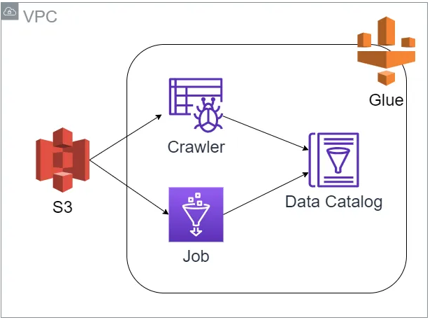

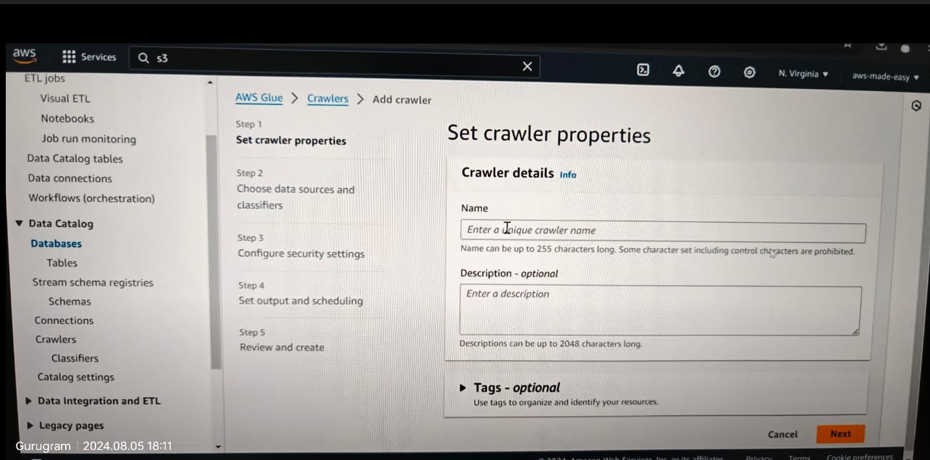

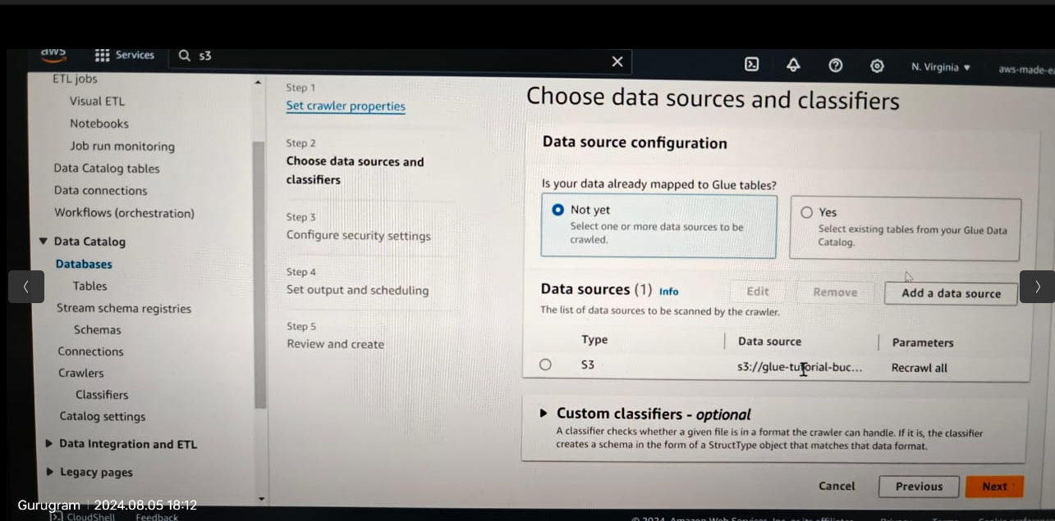

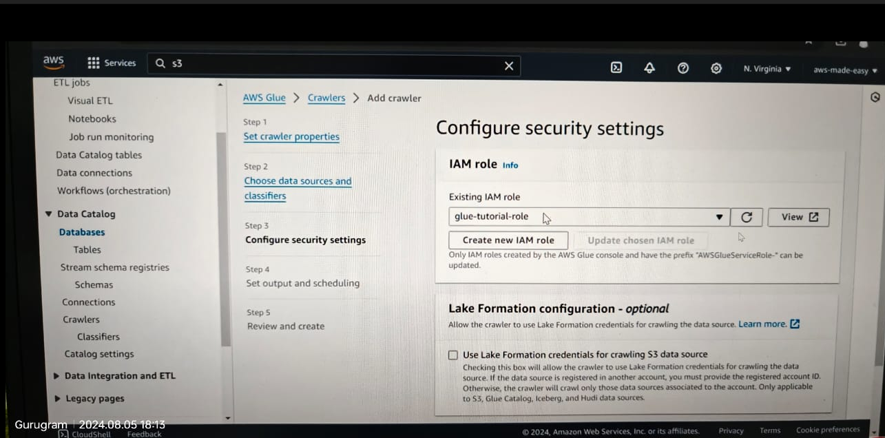

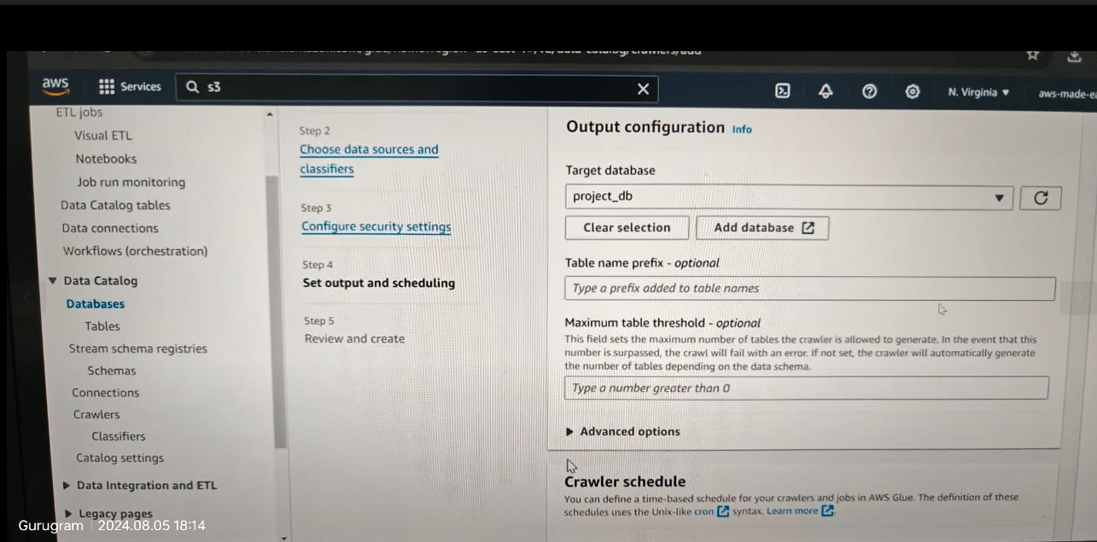

We need to create a IAM role to create a crawler, and need to give permissions(add policies) of s3 for table access, cloudwatch logs for logs and aws glue full access.

- AWS Glue ETL
- ETL jobs
- Triggers
- Workflows

Options in glue crawler
glue studio
glue catalog

it provides schema discovery option.

Connections:
- An AWS Glue connection is a configuration object that enables AWS Glue to connect to your data stores.
- It contains the necessary connection details such as the database endpoint, username and password which glue uses to establish a connection to data sources like amazon redshift or other JDBC-compliant databases.
- While creating connection we specify the data source like redshift etc and data instances , user name and password to connect the DB instances.
- So, next time we connect to that db instance, we don’t need to give credentials manually.

AWS Glue ETL jobs

- ETL job to transform your data.
- Leverage the power of spark.
- Serverless.
- Create the ETL jobs visually or bring your own script with business logic.

Glue sample ETL script:

import sys
from awsglue.transforms import *
from awsglue.utils import getResolvedOptions
from pyspark.context import SparkContext
from awsglue.context import GlueContext
from awsglue.job import Job

args = getResolvedOptions(sys.argv, ["JOB_NAME"])
sc = SparkContext()
glueContext = GlueContext(sc)
spark = glueContext.spark_session
job = Job(glueContext)
job.init(args["JOB_NAME"], args)

# Script generated for node S3 bucket
S3bucket_node1 = glueContext.create_dynamic_frame.from_catalog(
database="yyz-tickets", table_name="tickets", transformation_ctx="S3bucket_node1"
)

# Script generated for node ApplyMapping
ApplyMapping_node2 = ApplyMapping.apply(
frame=S3bucket_node1,
mappings=[
("tag_number_masked", "string", "tag_number_masked", "string"),
("date_of_infraction", "string", "date_of_infraction", "string"),
("ticket_date", "string", "ticket_date", "string"),
("ticket_number", "decimal", "ticket_number", "float"),
("officer", "decimal", "officer_name", "decimal"),
("infraction_code", "decimal", "infraction_code", "decimal"),
("infraction_description", "string", "infraction_description", "string"),
("set_fine_amount", "decimal", "set_fine_amount", "float"),
("time_of_infraction", "decimal", "time_of_infraction", "decimal"),
],
transformation_ctx="ApplyMapping_node2",
)

# Script generated for node S3 bucket
S3bucket_node3 = glueContext.write_dynamic_frame.from_options(
frame=ApplyMapping_node2,
connection_type="s3",
format="glueparquet",
connection_options={"path": "s3://DOC-EXAMPLE-BUCKET", "partitionKeys": []},
format_options={"compression": "gzip"},
transformation_ctx="S3bucket_node3",
)

job.commit()

